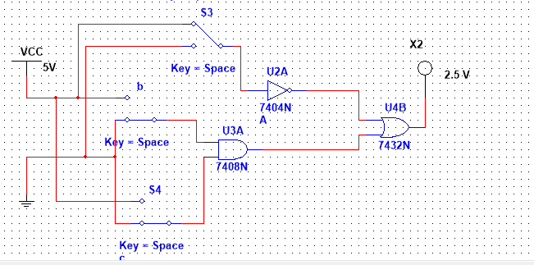Example#1

Truth Table

|  |  |  |  |  |  |
| --- | --- | --- | --- | --- | --- |
| A | A | B | c | B.c | A+B.c |
|  |  |  |  |  |  |
|  |  |  |  |  |  |
|  |  |  |  |  |  |
|  |  |  |  |  |  |
|  |  |  |  |  |  |
|  |  |  |  |  |  |
|  |  |  |  |  |  |

Task 01

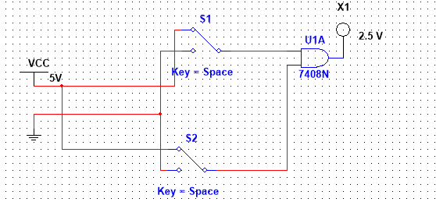

Task 02

(A+B+C)**.** (A+C+D)**.** (B+C+D)

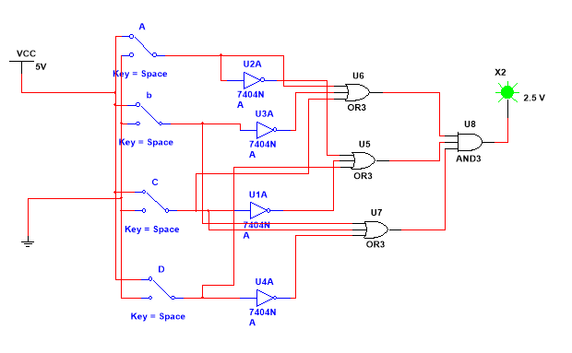

Truth Table:

|  |  |  |  |  |  |  |  |  |  |  |  |
| --- | --- | --- | --- | --- | --- | --- | --- | --- | --- | --- | --- |
| A | B | C | D | A’ | B’ | C’ | D’ | A+B’+C | A+B’+C | A+B’+C |  |
|  |  |  |  |  |  |  |  |  |  |  |  |
|  |  |  |  |  |  |  |  |  |  |  |  |
|  |  |  |  |  |  |  |  |  |  |  |  |
|  |  |  |  |  |  |  |  |  |  |  |  |
|  |  |  |  |  |  |  |  |  |  |  |  |
|  |  |  |  |  |  |  |  |  |  |  |  |
|  |  |  |  |  |  |  |  |  |  |  |  |
|  |  |  |  |  |  |  |  |  |  |  |  |
|  |  |  |  |  |  |  |  |  |  |  |  |
|  |  |  |  |  |  |  |  |  |  |  |  |
|  |  |  |  |  |  |  |  |  |  |  |  |
|  |  |  |  |  |  |  |  |  |  |  |  |
|  |  |  |  |  |  |  |  |  |  |  |  |
|  |  |  |  |  |  |  |  |  |  |  |  |